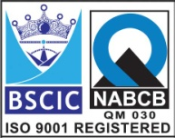****

**PTFE Lined Ball Valve ASA150#** (Flanged End Lever Operated)

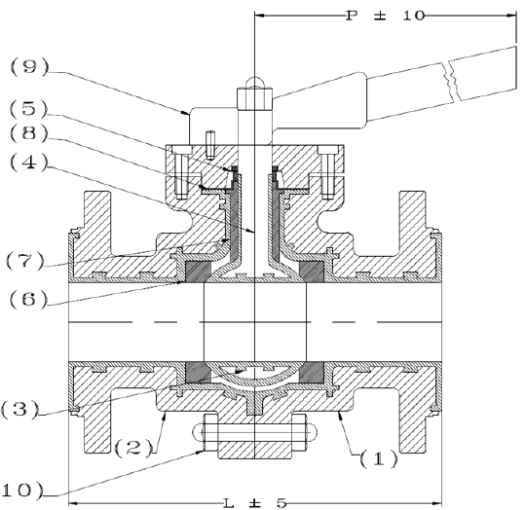

**Features: -**

* Temp: Up to 200 C (PFA Lining)
* Temp: Up to 160 C (FEP Lining)
* Lining Thickness: Minimum 3mm
* Lining Spark Test: 15 KV DC
* End Connection – Flanged End, RF
* Flange Drilling – As per ANSI B16.5, 150#
* Face to Face – As per ANSI B16.10
* Operation – Manual Hand Lever Operated

**Testing Standard: -**

|  |  |  |
| --- | --- | --- |
| Test Pressure in PSIG | | |
| Test | Hydrostatic | Air |
| Pr. Rating | 150# |
| Body | 145 (9.8 Kg/cm2) |  |
| Seat | 145 (9.8 Kg/cm2) |  |

**Material: Dimension:-**

|  |  |  |  |  |  |  |  |  |  |  |  |  |  |  |
| --- | --- | --- | --- | --- | --- | --- | --- | --- | --- | --- | --- | --- | --- | --- |
| **No.** | **Part Name** | **Materials** |  | **Size** | **15** | **20** | **25** | **40** | **50** | **65** | **80** | **100** | **125** | **150** |
| 01 | Body | D.I/ WCB / SS304/ SS316  With PFA or FEP Lining |  | **L** | 108 | 118 | 127 | 165 | 178 | 190 | 203 | 229 | 254 | 264 |
| 02 | Side Piece |  | **OD** | 89 | 98 | 108 | 127 | 152 | 178 | 190 | 229 | 254 | 279 |
| 03 | Ball |  | **PCD** | 60 | 70 | 79 | 98 | 121 | 140 | 152 | 190 | 216 | 241 |
| 04 | Stem | Integral With Ball |  | **RF Dia.** | 35 | 43 | 51 | 73 | 92 | 105 | 127 | 157 | 186 | 267 |
| 05 | Gland Bush | CS / SS 304/ SS316 |  | **No of Hole** | 4 | 4 | 4 | 4 | 4 | 4 | 4 | 8 | 8 | 8 |
| 06 | Seat Ring | PTFE / GFT / CFT |  | **Hole Dia** | 16 | 16 | 16 | 16 | 19 | 19 | 19 | 19 | 22 | 22 |
| 07 | Gland Seal | PTFE / GFT / CFT |  |  |  |  |  |  |  |  |  |  |  |  |
| 08 | Gland Washer | CS / SS 304/ SS316 |  |  |  |  |  |  |  |  |  |  |  |  |
| 09 | Hand Lever | CS /SS |  |  |  |  |  |  |  |  |  |  |  |  |
| 10 | Bolt & Nut | B7 / 2H / SS304 / SS316 |  |  |  |  |  |  |  |  |  |  |  |  |
|  |  |  |  |  |  |  |  |  |  |  |  |  |  |  |
|  |  |  |  |  |  |  |  |  |  |  |  |  |  |  |

**Due to continuous development Program, the design & data given in this leaflet are subject to change without prior notice.**

**ANITA ENGINEERING WORKS**



58-59, Narayan Estate, Opp. Shree Ram Estate, Nr. CMC Ltd. Odhav, Ahmedabad-382415, Gujarat, India

Phone: +91 79 22974101, Fax: +91 79 22875014

Email: eascovalves@gmail.com, eascovalves@yahoo.com, Web: [www.eascovalve.com](http://www.eascovalve.com)